Pre-requisities for Web Services:
- Every web service runs on java portal. So Portal is necessary to run a web service.
- Auth Object: SAP_J2EE_ADMIN.

Steps for creating a WEB SERVICE.

- Create one RFC enabled function module.

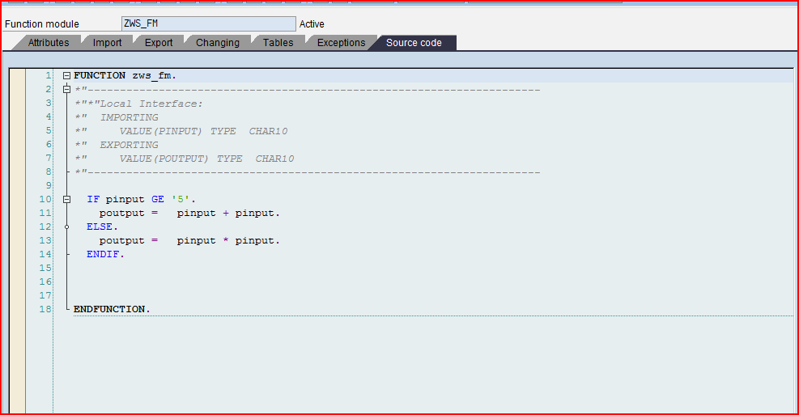

- Follow the following path in Function module.

UTILITIES->MORE UTILITIES->CREATING WEB SERVICE->FROM THE FUNCTION MODULE.

The following pop-up appears.

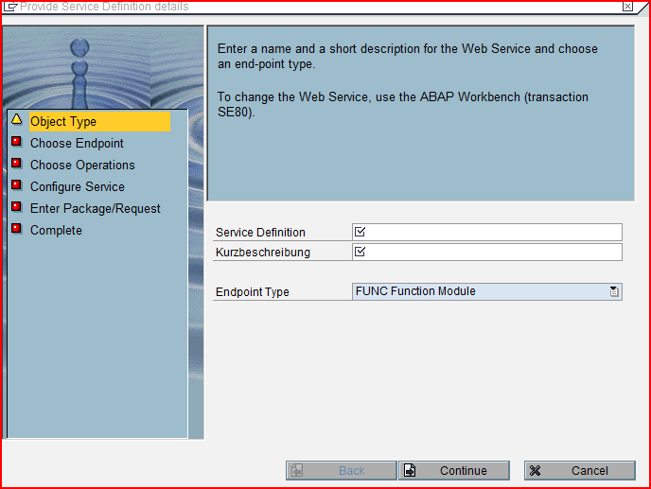

- Give the name of the Service Definition and its description.
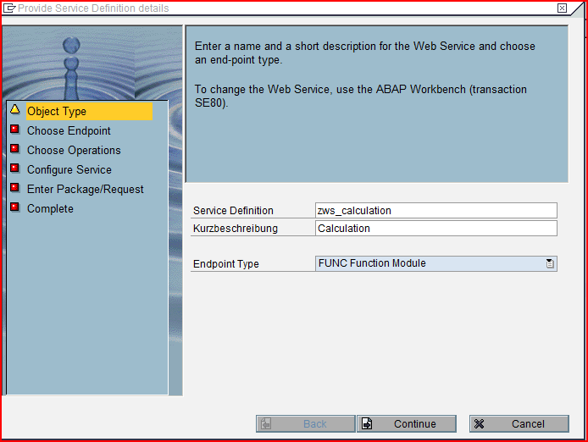

Click on the continue button.

4. The following screen appears.

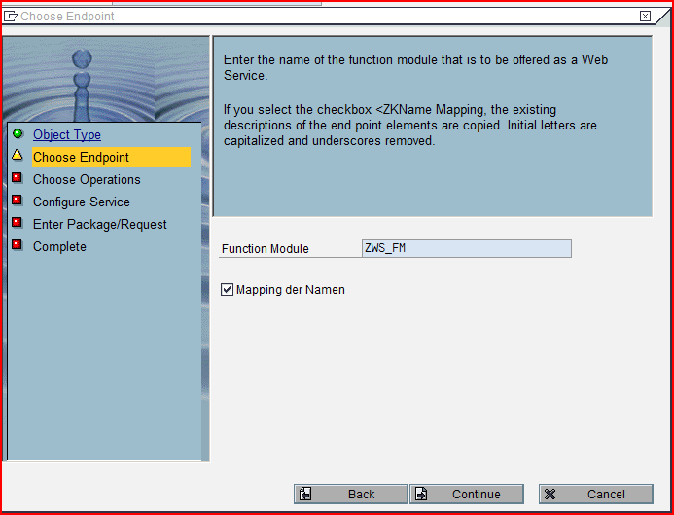

Click on the continue button

- The following screen appears.
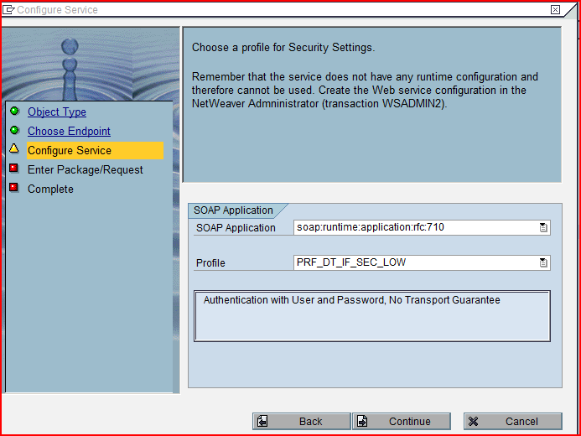

Choose the profile and Click on the continue button.

- The following screen appears.

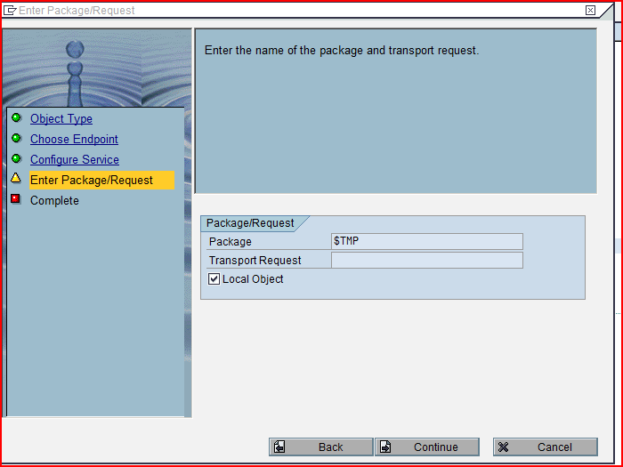

Store the web service in a request or as a local object and click on the continue button.

- The following screen appears.

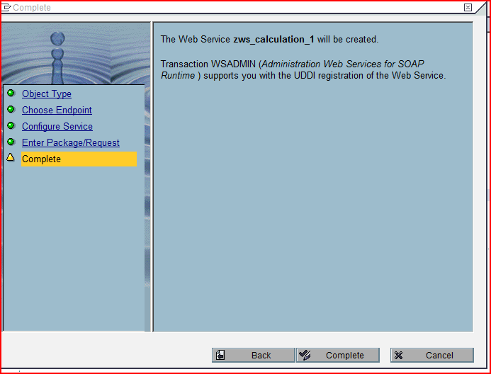

Click on the complete button.

- The web service has been created and to access that web service go to t-code ‘SOAMANAGER’.
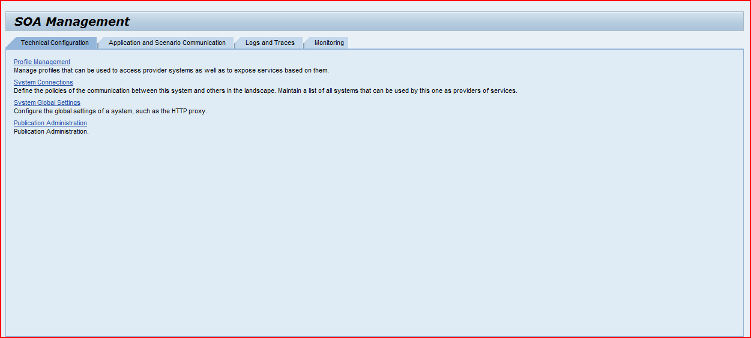

- Follow the following path in ‘SOAMANAGER’.

Application and Scenario Communication -> Single Service Administration.

The following screen appears.

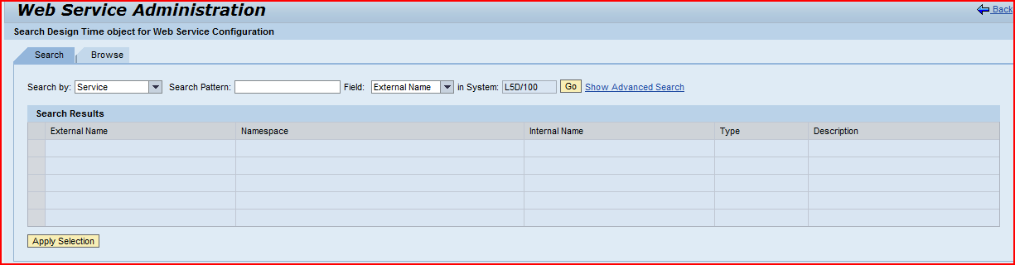

- In the search pattern input field give the name of the web service and click on the ‘GO’ button.

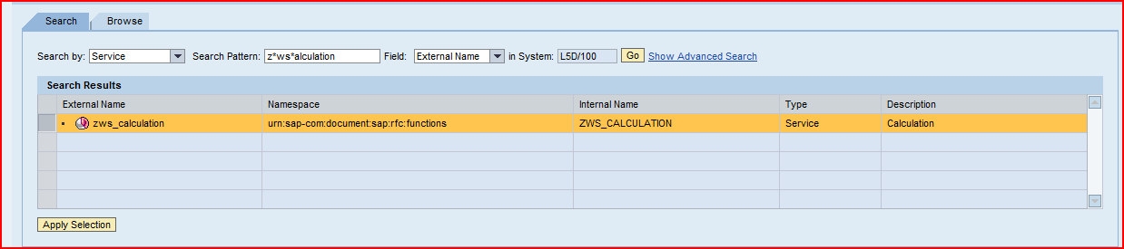

- Select the web service and click on ‘Apply Selection’.

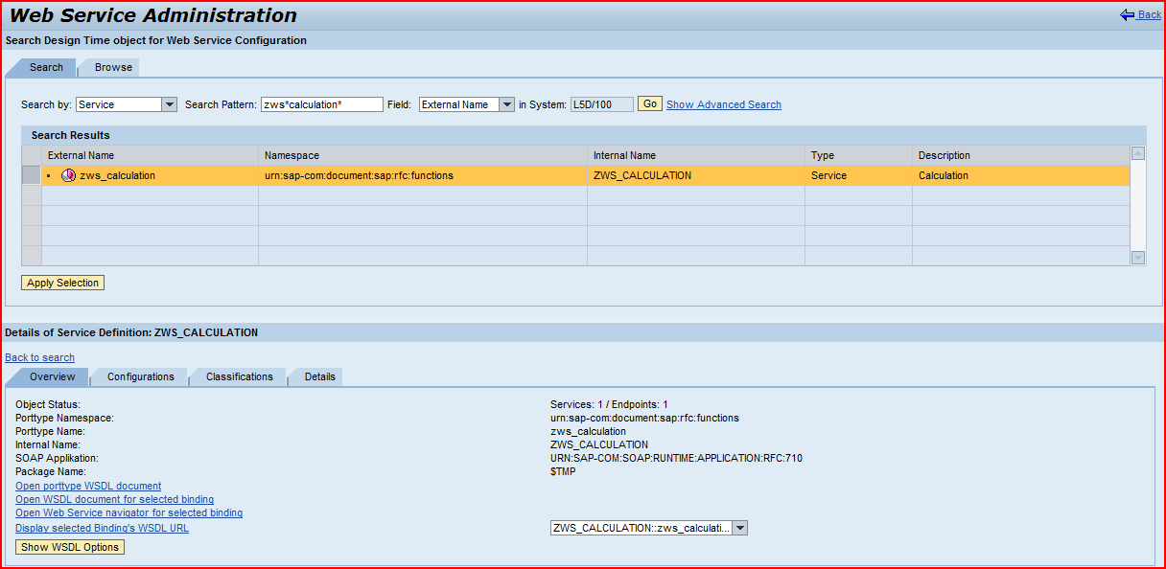

We get the details of the web service. The Link ‘Display Selected Binding WSDL URL’ gives the URL of WSDL (Web Service Definition Language) for a web service.

- Click on the Navigation Link ‘Open Web Service navigator for selected binding’ which will redirect us to the Java portal path.

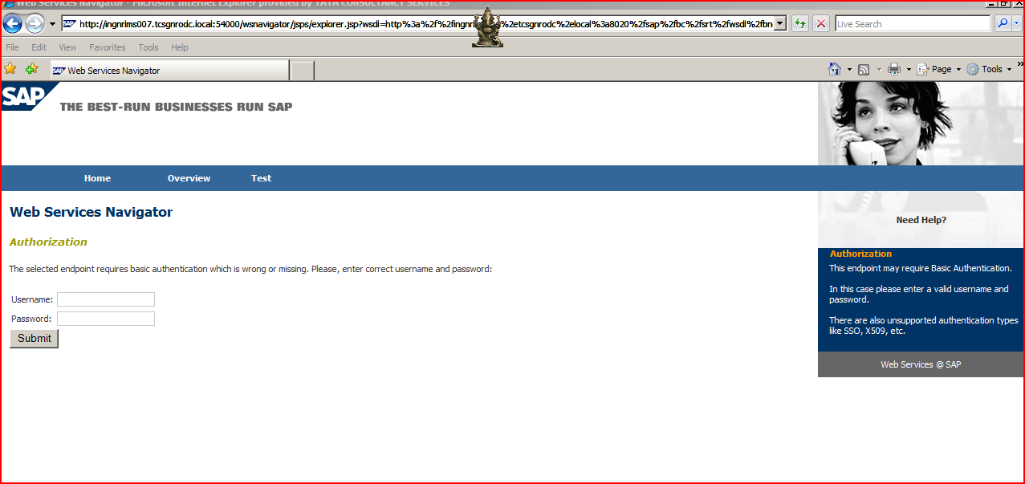

Provide the User name and Password and click on the submit button.

- The Following Screen appears.

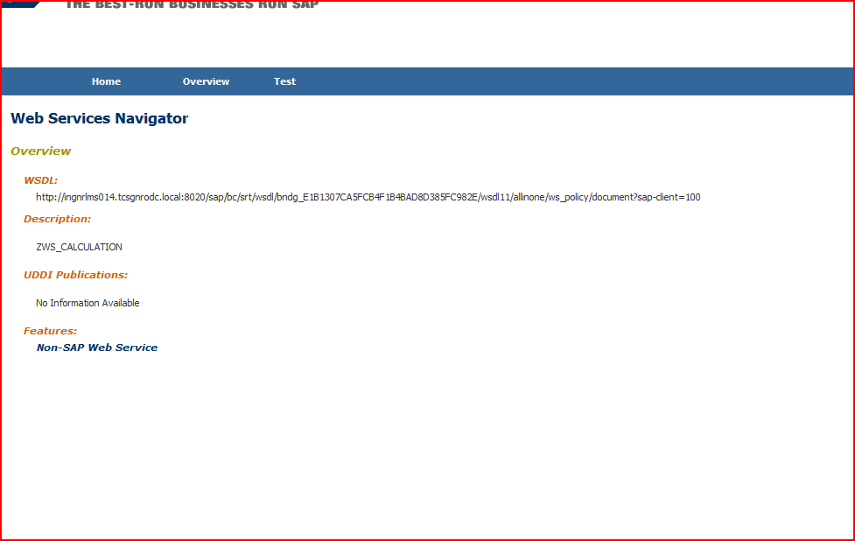

Click on the test button.

13. The following screen appears.

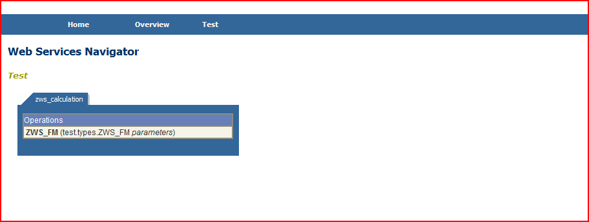

Click on the navigation link under Operations.

- In the next screen we will get the Input parameters of RFC FM. Provide the input and click on the send button. In the backend our RFC FM calls. (We can see by putting the breakpoint in FM).

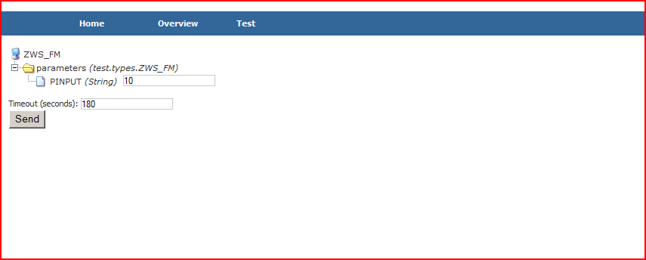

14. In the next screen we can see the response of our request.

